

Data Mining Project

Report on

Prediction of Sale Trends for an Online Retailer

Hemanth Kumar Kothapalli
Sri Nikita Desetty Trilok Dhanekula

Table of Contents

Introduction

Research Question

Literature Review

Data and its sources

Data Gathering

Data Cleaning and Preprocessing

Reducing Data Dimensions

Data Partition

Methodology

Multiple Linear Regression

Decision Tree

Random Forest Model

Results

Conclusions and Recommendations

Conclusion

Recommendations

References

Appendix

Data Dictionary

Dummy Variables

Output for Codes

Data Visualization

1. Introduction

Businesses today need to effectively manage sales, inventory, and operations to remain competitive. Analyzing sales trends, forecasting future sales, and optimizing processes are crucial. Additionally, minimizing product returns is important for improving customer satisfaction and operational efficiency. This analysis aims to explore relationships that could explain and address these business challenges using the given dataset.

Research Question

What are all the factors that influence sales trends, and how do they differ across various factors such as products/items, geographical areas, time periods, and other relevant variables?

In this project, we aim to analyze the sales trends, which provide insights into how customers engage with different products. This analysis uncovers consumer preferences and purchasing behaviors, which are critical for developing effective marketing strategies. Examining sales variations across regions can reveal geographical preferences and market opportunities. This information is essential for conducting targeted marketing campaigns and tailoring products to specific regional needs. Moreover, predictive analytics can be employed to inform budgeting decisions, pricing strategies, and the development of marketing plans.

Literature Review

Bhupathiraju and Raghavendra utilized prior transactional data to demonstrate the applicability of customer segmentation strategies for an online retail store. They employed RFM analysis and K-means clustering algorithms to categorize customers based on their purchase histories and behaviors. The study covered key aspects such as predicting customer lifetime value, identifying product associations, and conducting further analysis on the items purchased by each customer group. The authors concluded that meticulous data preparation and careful model interpretation are essential for extracting valuable insights.

In our current study, we aim to build predictive models to forecast future customer value/spending, likelihood of churn, and response to promotions. To achieve this, we will employ techniques such as regression and random forests. Furthermore, our goal is to construct predictive models for forecasting future sales patterns and conduct analyses.

Data and its sources

  - Data Gathering

For this research, we have utilized the “Online Retail” dataset, which encompasses 541,909 observations across 8 variables. This substantial dataset offers a comprehensive and varied source of information, facilitating in-depth analysis and deriving meaningful insights into numerous facets of the subject area. Moreover, the abundance of data points enables the identification of trends and patterns, as well as the exploration of correlations and connections between the different variables present in the dataset.

Data Cleaning and Preprocessing

The dataset initially contained a total of 136,534 missing values, with 135,080 of them belonging to the CustomerID variable and 1454 to the Description variable. After omitting these null observations, the dataset was reduced to 406,829 observations across 8 variables. Additionally, we conducted a comprehensive examination of the dataset to ensure its integrity and validity. During this process, we identified the presence of extreme outliers or data points that significantly deviated from the rest of the data distribution. These outliers were observed across multiple critical variables and had the potential to skew our research findings, potentially introducing bias into our conclusions. To mitigate this issue, we removed these extreme outliers from the dataset. This step was essential to enhance the accuracy and relevance of our subsequent analyses.

Unit Price: The boxplot for the unit price variables shows the presence of an extreme high outlier, represented by a data point significantly higher than the rest of the distribution. The existence of such an extreme value can potentially introduce bias and distort measures central tendency, such as the mean and the median. (Refer Figure 1)

Quantity: The boxplot for the quantity variable reveals the presence of outliers that are significantly larger than the median value. These outliers could potentially represent data entry errors or bulk purchases. The overall distribution appears skewed, suggesting that most orders consist of relatively small quantities. To obtain accurate predictive analysis and reliable models, it is essential to address these outliers through data transformation or cleaning techniques. (Refer Figure 2)

Country: The barplot displays the frequency of buyers across various countries. The plot reveals that the United Kingdom dominates in terms of sales volume when compared to the next four highest countries, which are Germany, France, EIRE, and Belgium, where sales figures are significantly lower. The substantial contribution of the United Kingdom to the overall sales aligns with the fact that the company’s headquarters

is located there. This suggests a strong influence of the domestic market on the organization’s sales performance and success. (Refer figure 7)

Reducing Data Dimensions

We have removed all observations from the UnitPrice variable where the value is less than or equal to 0.01, as these records are missing price information and need to be omitted to ensure a clean dataset. Eight new dummy variables have been created to supplement the original variables.

We have created a ‘seasons’ variable, divided into four groups (Winter, Spring, Summer, Fall) to identify trends and understand customers’ seasonal spending behavior. Additionally, one of the newly created dummy variables is InvoiceDummy, a binary variable with values of 0 and 1. A value of 1 represents InvoiceIds starting with ‘C’, indicating canceled orders, while a value of 0 denotes successful orders. This variable’s introduction allows for the separation of sales with returns or cancellations from the overall population.

Another dummy variable, TopSales, has been introduced. This variable classifies 183244 observations as low sales and 192914 observations as high sales, representing an almost 1:1 distribution, which can be considered fairly balanced. In this case, it can be concluded that the dataset Is neither undersampled nor oversampled.

Additionally, Log_Sales and Log_UnitPrice variables have been created to facilitate further analysis. Given the balanced nature of the dataset, it could be directly utilized for training and predicting classification models without the need for additional sampling techniques.

  - Data Partition
The data has been divided into two subsets: 60% for training, consisting of 226294 observations, and 40% for validation, containing 150864 observations. Both subsets have 16 variables each, consisting of 8 original variables and 8 dummy variables. By allocating a larger portion of the data for training, we ensure that our models undergo a comprehensive learning phase, allowing them to capture the underlying trends and patterns across various variables. The validation subset acts as new, unseen data for models, enabling us to assess how well our predictions generalize to data that was not used for training the models.

- Methodology
Target variable - Log_Sales
Predictor variables – Log_UnitPrice + UKCountryGroup + Season + TopSale

  - Multiple Linear Regression
Multiple Linear Regression is a way to study how predictor variables affect target variable at the same time. It’s a statistical technique that helps us understand the relationship between the independent variable sales and other variables that might influence it.

The regression analysis results reveal that seasonal effects seem to have a positive impact on sales, with Spring, Summar and Winter being associated with increases in Log_Sales, as indicated by their positive coefficients. Sales in the UK have a significant negative effect on the quantities sold with a coefficient of -0.197. The model’s R-squared value of 0.639 implies that approximately 63.9% of the variation in Log_Sales can be explained by these independent variables. (Refer Output 1)
  - Decision Tree Model
A Decision tree model is a tree-like structure where internal nodes represent feature tests, branches represent the outcomes of those tests, and leaf nodes represent the final predictions or decisions. It recursively partitions the input data based on the most informative features, creating a flowchart-like model that can make accurate predictions or classifications.
The decision tree model splits the data based on the most informative predictor variables to create subgroups with distinct average values of the target variable. The model’s mean square error value of 0.61908 provides an estimate of the average magnitude of the prediction errors made by the decision tree model. (Refer Output 2)

  - Random Forest Model
Random Forest Model is an ensemble learning method that constructs multiple decision trees and combines their predictions. It introduces randomness to reduce overfitting, handles non-linear relationships well, is robust to outliers, and provides feature importance insights.
The model output shows a mean of squared residuals of 0.422, indicating that the average squared difference between predicted and actual sales values during training. The percentage of variance by the model is 60.39%. When the predictions are made on the test dataset, the root mean squared error between the predicted and actual sales values in the test set is calculated as 0.651.
- Results
The three analysis techniques that we have applied are Multiple Linear Regression, Decision Tree Model, and Random Forest Model as they excel at handling complex relationships and noisy observations, while offering valuable insights into the relevance of each predictor variable.
The Multiple Linear Regression model underwent multiple rounds of refinement. We experimented with different predictor variable combinations and applied various transformations. For the Decision Tree model and the Random Forest model, the iterations focused on determining the optimal number of branches and trees to strike a balance between accuracy and overfitting.

- Conclusion and Recommendations
  - Conclusion
Model | Root Mean Square Error
Multiple Linear Regression | 0.6251
Decision Tree | 0.6190
Random Forest Model | 0.6517
  - Recommendations
Based on the RMSE values, the Decision Tree model appears to be the most accurate, followed by Multiple Linear Regression and then the Random Forest Model.
Based on the predictors and insights gained from the models used, businesses are advised to implement the following tactics to enhance their sales and their fluctuations across various dimensions:
Price: Employ various dynamic pricing strategies that can be adjusted to optimize revenue and profitability.
Seasons: Strategically plan inventory and launch targeted marketing initiatives tailored to different seasons, leveraging observed seasonal sales fluctuations.
Geographic Location: Customize product offerings and marketing approaches to suit specific regional markets.
Sales: Customer loyalty repeat business by offering incentives such as discounts for frequent buyers or implementing loyalty programs.
- References
Bhupathiraju, Gowtham Varma, and V. R. T. S. Raghavendra. "Data mining for the online retail industry: Customer segmentation and assessment of customers using RFM and k-means." (2022).
- Appendix
  - Data Dictionary
Variables | Type | Description
InvoiceNo | Categorical | A 6-digit integral number uniquely assigned to each transaction. If this  code starts with letter 'c', it indicates a cancellation
StockCode | Categorical | A 5-digit integral number uniquely assigned to each distinct product
Description | Categorical | Product name
Quantity | Integer | The quantities of each product per transaction
InvoiceDate | Date | The day and time when each transaction was generated
UnitPrice | Continuous | Product price per unit
CustomerID | Categorical | A 5-digit integral number uniquely assigned to each customer
Country | Categorical | Name of the country where each customer resides
  - Dummy Variables

Variable | Type | Description
UkCountryGroup | Categorical | Countries are grouped into two: Either Uk or others
Season | Categorical | Grouped based on Date into Spring, Summer. Fall and Winter
InvoiceDummy | Categorical | Divided into Cancelled or not.
Log_Sales | Numerical | Log transformation applied on Quantity
Log_UnitPrice | Numerical | Log transformation applied on UnitPrice
TopSale | Categorical | Divided into high sales or low sales

8.3 Outputs
Output 1: Multiple Linear Regression
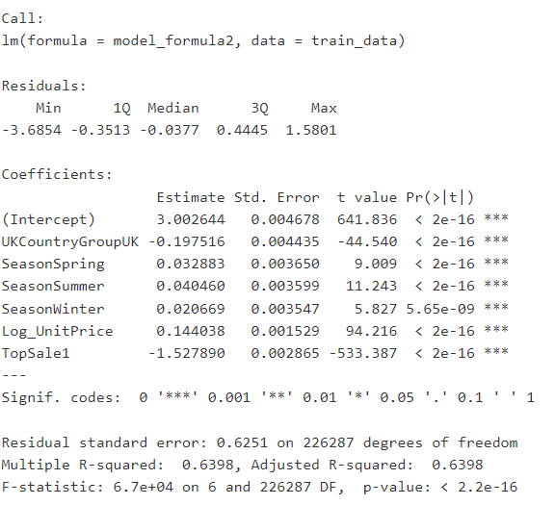

Output 2: Decision Tree
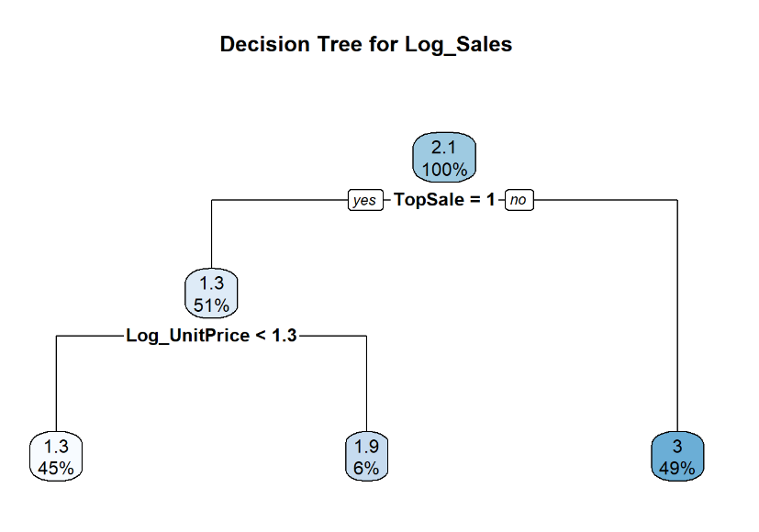


Output 3: Random Forest Model
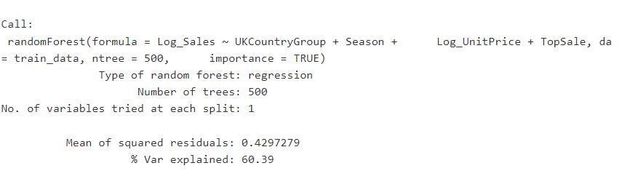

  - Data Visualizations
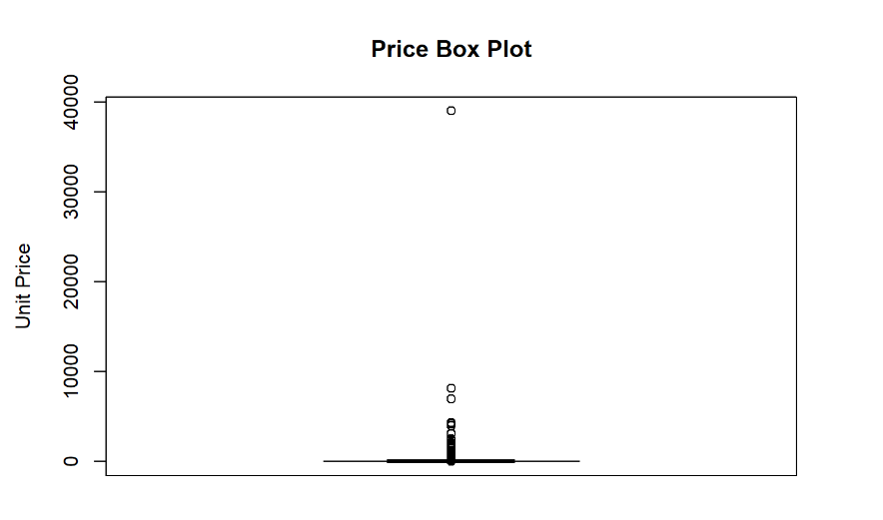
Figure 1: Box plot of Unit Price before handling outliers
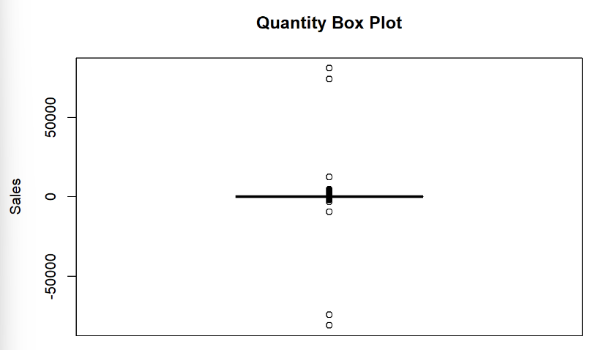

Figure 2: Box plot of Quantity before handling outliers
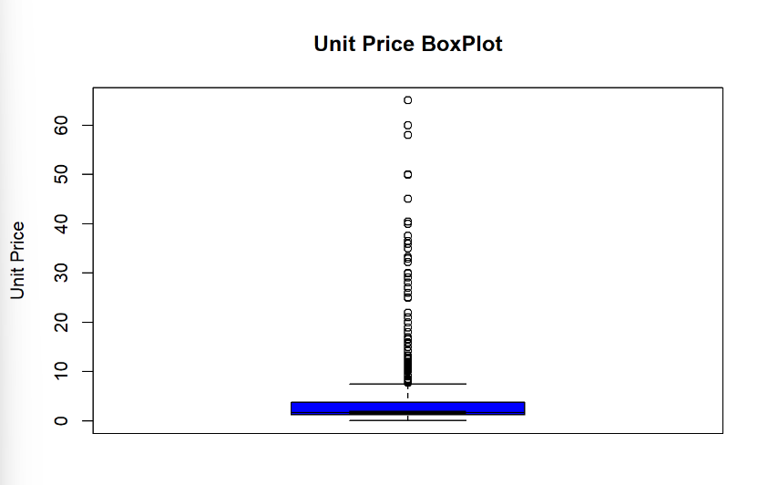

Figure 3: Box plot of Unit Price after handling outliers

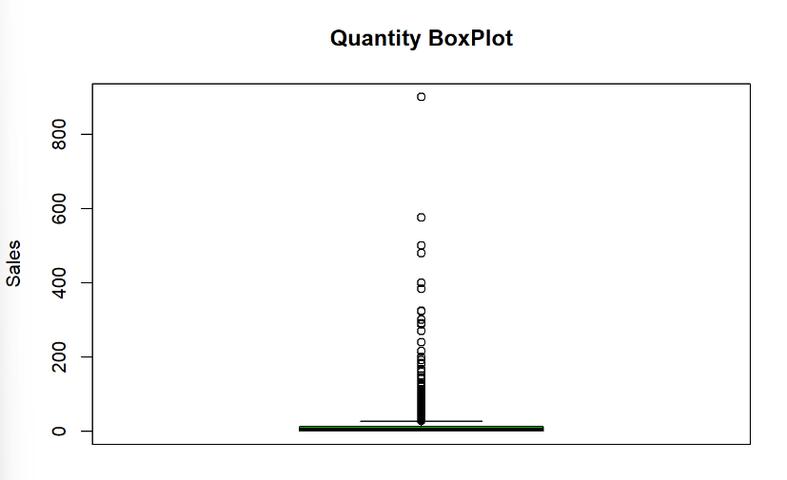

Figure 4: Box plot of Quantity after handling outliers

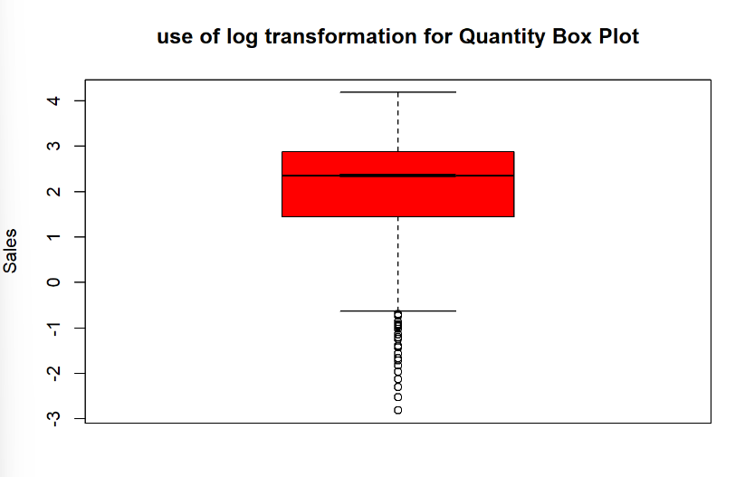

Figure 5: Box plot of Quantity after applying log transformation

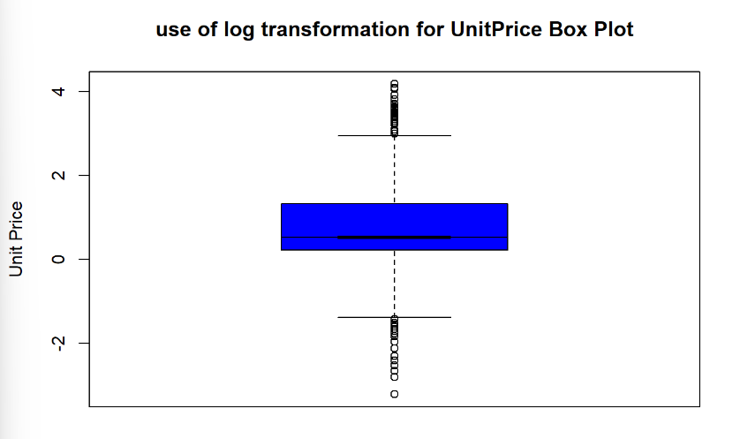

Figure 6: Box plot of UnitPrice after applying log transformation

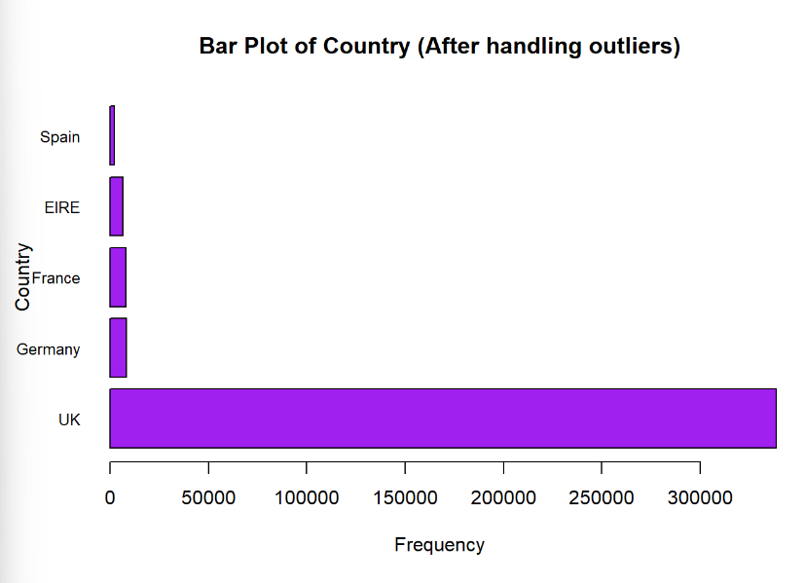

Figure 7: Bar Plot of Country

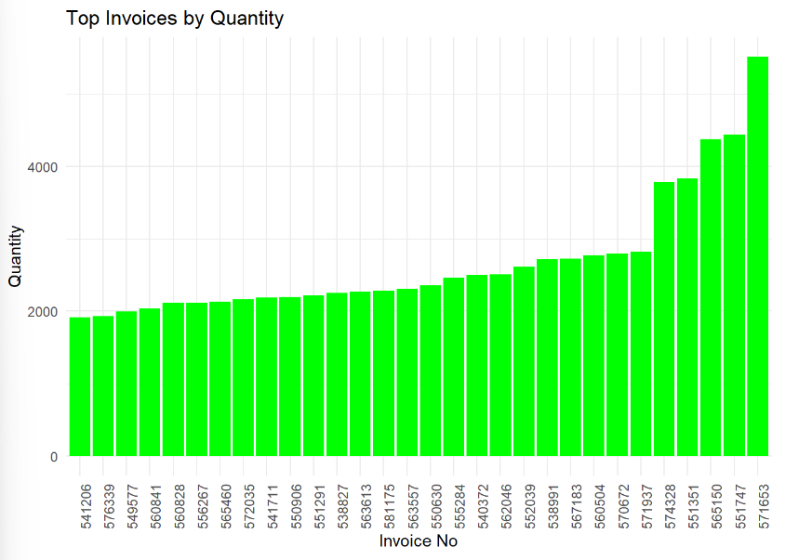

Figure 8: Top Invoices by Quantity

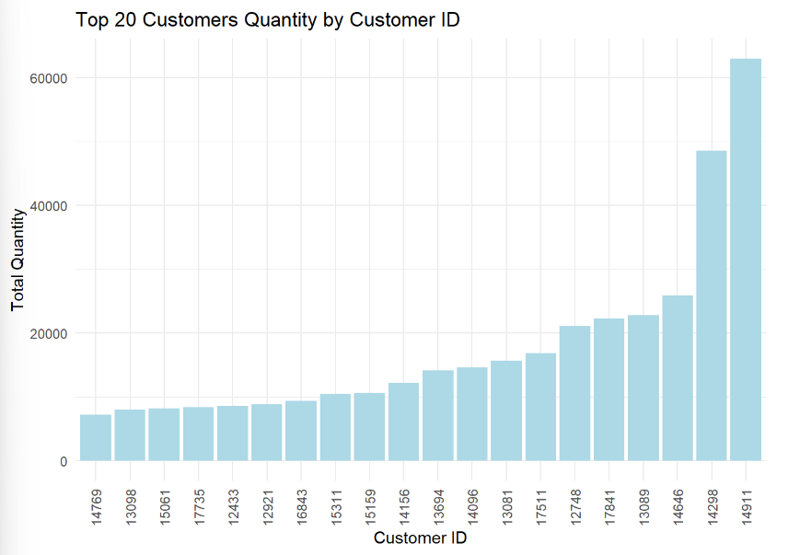

Figure 9: Top 20 customers Quantity by Customer ID

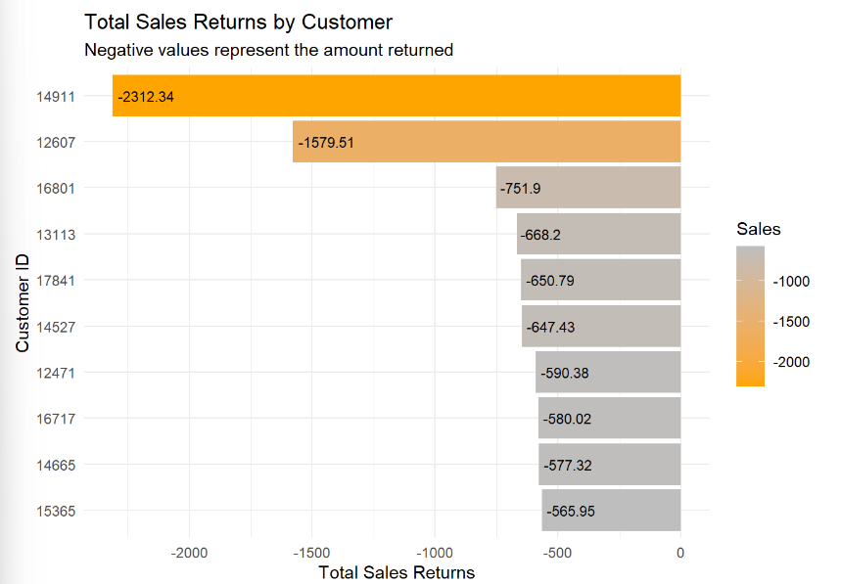

Figure 10: Total Sales Returns by Customers

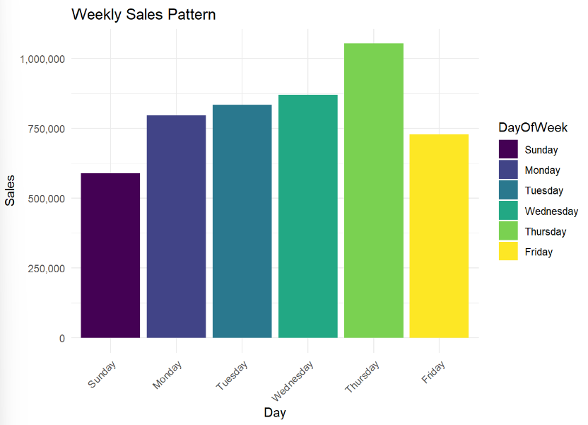

Figure 11: Weekly Sales Pattern

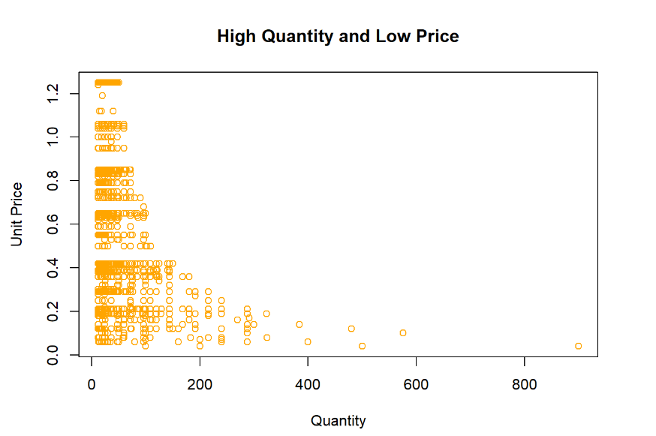

Figure 12: High Quantity and Low Price

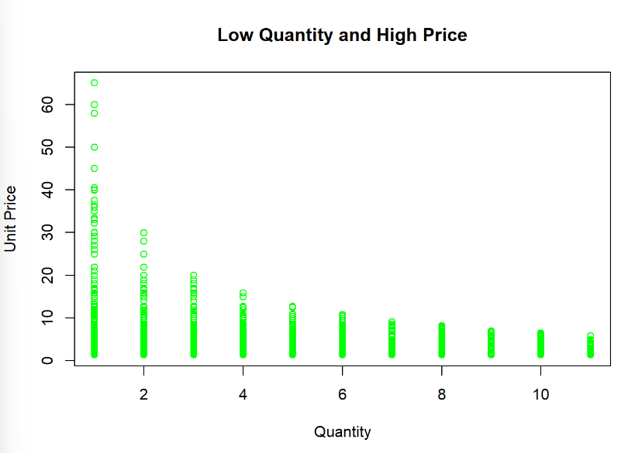

Figure 13: Low Quantity and High Price

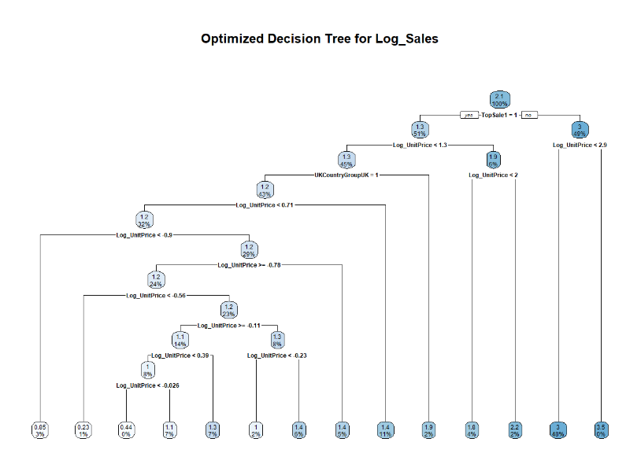

Figure 14: Optimized Decision Tree

